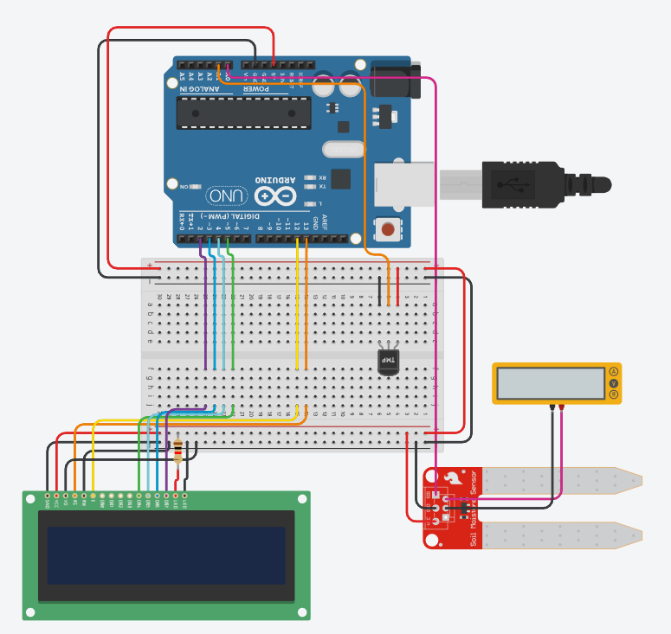
#include <LiquidCrystal.h>

LiquidCrystal lcd(13, 12, 5, 4, 3, 2); // RS, EN, D4, D5, D6, D7

void setup() {
Serial.begin(9600);
lcd.begin(16,2);
lcd.print("Initializing...");
delay(2000);
}

void loop() {
int TempSen = analogRead(A1);
float TempVolt = (TempSen / 1024.0) * 5.0;
float TempVal = ((TempVolt - 0.5) * 100);
Serial.print("========================== \n");
Serial.print("Temperature value: " + String(TempVal) + "\n");

int MoisSen = analogRead(A0);
float MoisVal = map(MoisSen, 0, 877, 0, 100);
Serial.print("Moisture value: " + String(MoisVal) + "\n");

lcd.clear();
lcd.setCursor(0, 0);
lcd.print("Temp: " + String(TempVal) + " C");

lcd.setCursor(0, 1);
lcd.print("Moist: " + String(MoisVal) + " %");
delay(500);

}

